Afry Nizam

DATABASE ASSIGNMENT

Contents

Activity 1 - DB design at Paws and Whiskers Animal Care. 21
Introduction 21
Conceptual & Logical Design 21
Entity-Relationship-Diagram. 22
Proper cardinality associations: 23
Figure 01: ER Diagram 24
Referential Integrity 25
1.2 Interface Design and Evaluation. 27
Add New Pet Screen: 27
Figure 02: Add new pet 27
Record Treatment Screen: 28
Figure 03: Record treatment 28
Search Treatment History Screen: 29
Figure 04: Search treatment history 29
User/System Requirement Control. 30
ERD and Logical schema analysis. 30
Conclusion 31
Activity 2 - Creating a database (Paws and Whiskers) 32
Introduction 32
2.1 SQL Development and Security. 32
SQL DDL - Creating Tables 32
Owner Table 32
Pet Table 33
Staff Table 33
Treatment Table 34
Junction Tables for M:N Relationships 35
SQL Interaction with Screens. 36
A) Adding a New Pet 36
B) Recording a Treatment 37
C) Deleting a Treatment Safely 38
Security Practices 39
1. User roles and permissions: 39
2. Authentication: 40
3. Safe SQL: 40
4. Input validation: 40
5. Backups: 40
6. Audit trail: 40
Evaluation - Build vs Needs 40
SQL Query Examples 41
Write SQL queries for each of the following tasks using the developed database. 43
Conclusion 45
Activity 3 – Testing and Feedback (Paws & Whiskers Animal Care) 47
Introduction 47
3.1 Testing 47
Test Plan Table 47
Choice of Test Data 48
Testing Results and Recommendations to improve testing. 49
Areas tested that require improvement: 49
3.2 User & Developer Feedback 50
Feedback Questionnaires 50
A) Non technical user (receptionist) 50
B) Developer / IT Technician 51
Other Feedback Major Recommendations. 51
Implication of the Feedback on the Design. 51
Conclusion 52
Activity 4 - Documentation (Paws and Whiskers Animal Care). 53
Introduction 53
Valuable aspects of technical documentation. 54
a) Database Tables 54
b) Relationships 54
c) Diagrams 55
d) Rules and Constraints of validation. 55
e) Security Information 56
Flowchart of Pet Treatment search System Diagram 56
User Guide 57
A) Adding Pets 57
B) Recording Treatments 57
D) Generation of Reports / search of history of treatment. 58
Tips for All Users 58
Next-Generation Improvements and Enhancements. 58
A) New Features 59
B) Performance Enhancements 59
C) interface and enhancement in the user experience. 59
Conclusion 59
References 61

Activity 1 - DB design at Paws and Whiskers Animal Care.

Introduction
Paws and Whiskers is a small pet clinic in York. Currently the clinic continues to use paper folders to hold the information about pet owners, their pets and the services that they receive. Paper records are cumbersome to search and are at times lost. These issues can be corrected with a simple relational database that would store all the forms of data (owners, pets, staff, treatments, equipment) as only one record and connect them using primary and foreign keys. This activity involves a description of what the users and the system need, an ERD with ties established correctly, transformation to a logical relational scheme, referential integrity, check normalisation to 3NF, three wireframes that represent the data model, and a conclusion and evaluation. It is designed using the best database and interface practices, outlined by Connolly and Begg (2015), Elmasri and Navathe (2016), Silberschatz et al. (2020), Nielsen (2020) and the MySQL documentation (2024).

Conceptual & Logical Design
User and System Requirements.

what the clinic staff would like the database to do:
- Register some pet owners and their pets. The reception personnel will receive the owners contact information (first name, last name, address, phone, email) and then input a pet belonging to the owner (pet name, species, breed, gender, date of birth). This is consistent with the world rule: a single owner may possess numerous pets (Connolly and Begg, 2015).

- Record treatments. Clinical employees will select a pet and provide information about every treatment type including type of treatment, date of treatment and date of next cheque-up. Sometimes, it may have more than one employee and multiple equipment items, which must also be stored (Elmasri and Navathe, 2016).

- Search treatment history. The staff should be capable of searching treatments with a pet name (and, optionally, an owner name, or even a date range) and returning a list of the treatments in chronological order. This will assist in future clinical decisions and follow-ups.

The guidelines that the database as such must operate:
- Referential integrity. The pets have to be connected to a valid owner, the treatments have to be connected to a valid pet, the treatment-staff connexions and the treatment-equipment connexions must refer to valid rows. Dates should be reasonable (as the date of birth of a pet cannot be future) (Silberschatz et al., 2020; MySQL, 2024).

- Reasonable performance and multiple access. Indexing should be done on major search fields like names, date and foreign key columns. The screens must be maintained as simple because it lowers the number of typing errors and helps to speed up the work in a busy clinic (Elmasri and Navathe, 2016; Nielsen, 2020).

Entity-Relationship-Diagram.
Entities whose primary keys are:
- Owner (OwnerID PK): FirstName, LastName, Address, Phone, Email.
- PetID PK: Name, Species, Breed, Gender, DOB, OwnerID FK
- Treatment (TreatmentID PK): Treatmenttype, Treatmentdate, Prescription, Nextcheckupdate, petid FK.
- Staff (StaffID PK): Firstname, Lastname, date of birth, qualification, position, phone, email, address.
- Equipment (EquipmentID PK): Equipmenttype, maintenance date, availability status.

Proper cardinality associations:
- Owner - Pet: 1 to many (an owner can have many pets, and the owner has a pet which is owned by him/her).
- Pet - Treatment: 1 to many (a treatment of one pet can have many treatments, treatment of a pet is one treat).
- Treatment: Staff: many-many (a treatment can have many staff and many treatments can be worked on by the same staff) - resolved by a junction table treatment staff.
- Equipment: many-to-many (a treatment may use multiple pieces of equipment and a piece of equipment may be used in multiple treatments) - addressed with a junction table
These normalizations are typical in the description of real-life many-to-many relationships of a relational database (Codd, 1970; Elmasri and Navathe, 2016).

Figure 01: ER Diagram

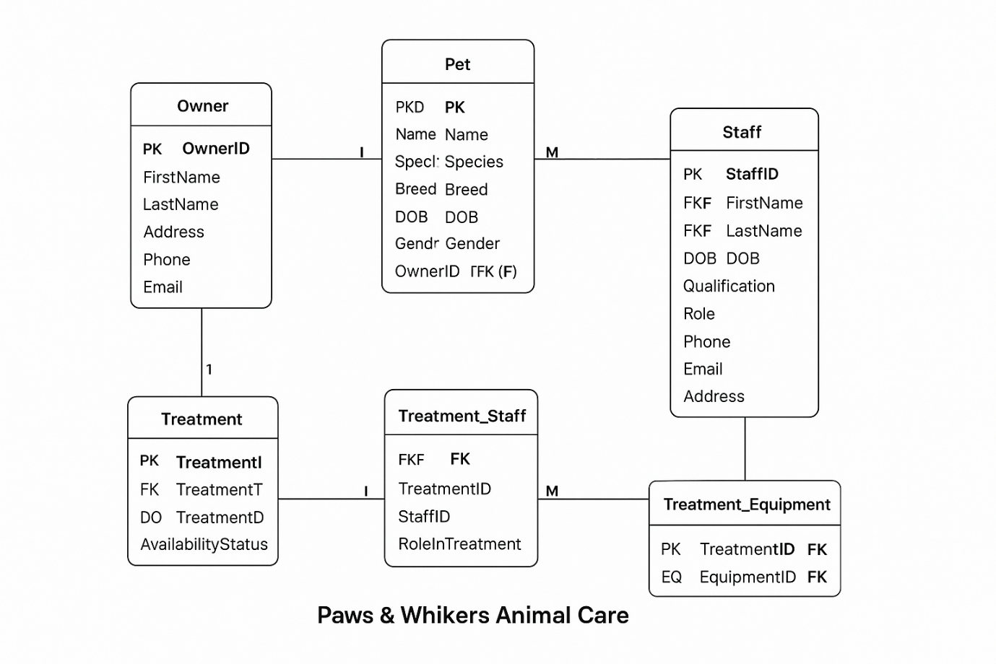

Logical Relational Schema

- Owner( OwnerID PK, FirstName, LastName, Address, Phone, Email )
- If this field is not included it is automatically created as hidden and the PK.<|human|>Pet( PetID PK, Name, Species, Breed, Gender, DOB, OwnerID FK - Owner.OwnerID ) is created automatically as a hidden field.
- Treatment( TreatmentID PK, Treatmenttype, Treatmentdate, Prescription, Nextcheckupdate fo Petid FK - Pet.Petid )
- Staff( StaffID PK,FirstName, LastName, DOB, Qualification, Role, Phone, Email, Address )
- Equipment( EquipmentID PK, Equipmenttype, maintenance date, Availability status)
- The TreatmentStaff ( Treatment ID FK - Treatment, StaffID FK - Staff, RoleInTreatment, PK(TreatmentID, StaffID) ) table.
- Treatment Equipment ( TreatmentID FK - Treatment, EquipmentID FK - Equipment, PK(TreatmentID, EquipmentID))
This framework supports all 1:M and M:N policies and eliminates redundant connexions (Connolly and Begg, 2015)

Referential Integrity
Referential integrity implies that all foreign-key values should be identical to a primary-key value in the associated table, otherwise the database will reject the insert or update (Silberschatz et al., 2020; MySQL, 2024).

In this system RI ensures:
  - The ownership always refers to an actual owner.
  - Treatment.PetID will always refer to an actual pet.
  - The TreatmentStaff and TreatmentEquipment rows always have references to the existing treatments, staff and equipment.
Why it matters:
  - Its use prevents the creation of orphans (such as an unlinked treatment).
  - Manages the clinical record in a way that it can be used in audits and follow-ups.
  - Minimises errors because screen can restrict options to available dropdown lists (Nielsen, 2020).
  - Deletes are safer since there is a need to delete treatment, but first, the link rows have to be deleted (MySQL, 2024).

Normalisation (1NF, 2NF, 3NF)
- 1NF: The columns at the table hold single and atomic values. The groups are not repetitive. Race and Genre are distinct. DOB is stored as a date. Address may be stored as a single field in this coursework but may be subdivided later.
- 2NF: No attribute is a function of more than a component key. Primary keys are single columns in most of the tables. The junction tables are composite but other fields (such as RoleInTreatment) rely on them as a single entity - meets 2NF (Elmasri and Navathe, 2016).
- 3NF: Non key attributes are also not related to other non key attributes. Age is not stored with us since it can be determined by DOB - eliminates update anomalies
Schemas 3NF. This eliminates redundancy, eliminates update issues and provides reasonable performance to a small clinic.

1.2 Interface Design and Evaluation.

Add New Pet Screen:

Figure 02: Add new pet
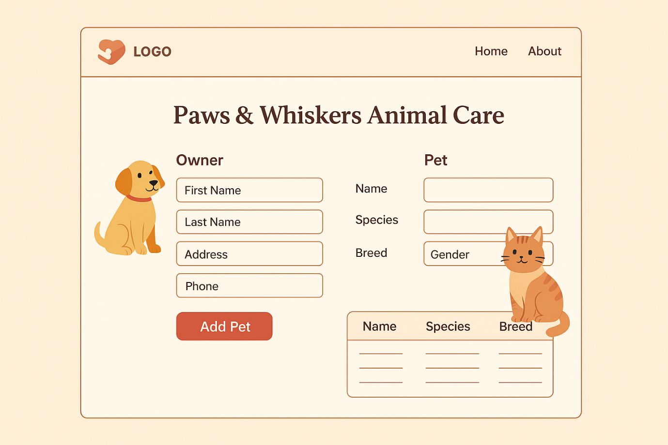

- Fields: Pet Name, Species, Breed, Gender (radio), Owner (searchable dropdown with + button to add new owner).
- Behaviour: Clicking on save button has to go to a row to choose Pet and the OwnerID.

Record Treatment Screen:

Figure 03: Record treatment
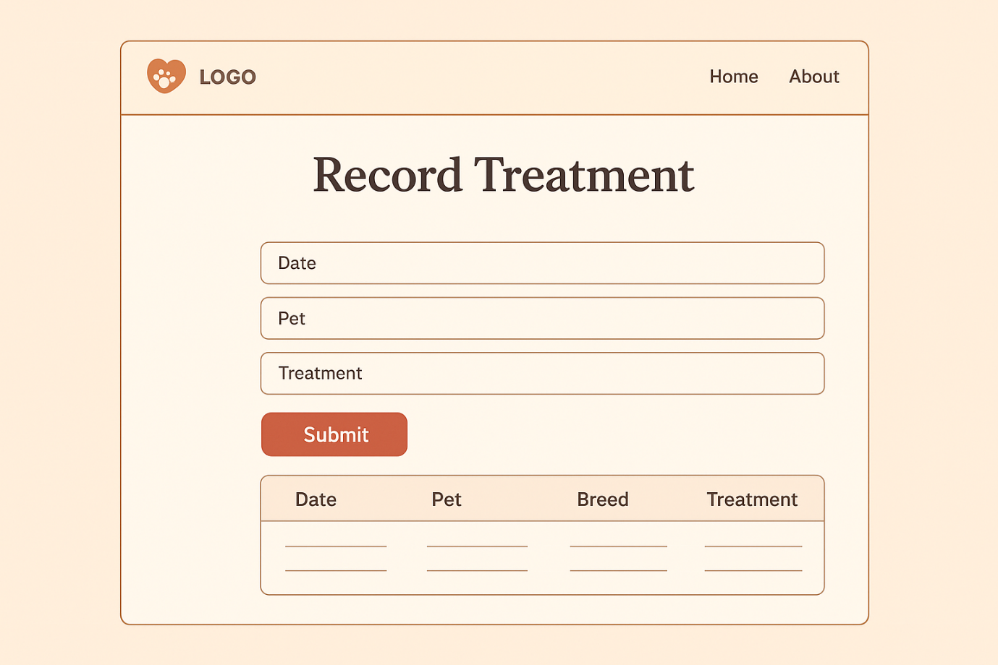

- Fields: Treatment Type (dropdown), date, prescription, next Cheke-up date (must be same or future of TreatmentDate) (search), pet (search), staff (search + add chips to add more), equipment (search).
- Behaviour: The initial submit the app behaviour is typed in the Treatment and the rows of treatment breed and date. One of the treatment will have to be selected.

Search Treatment History Screen:

Figure 04: Search treatment history
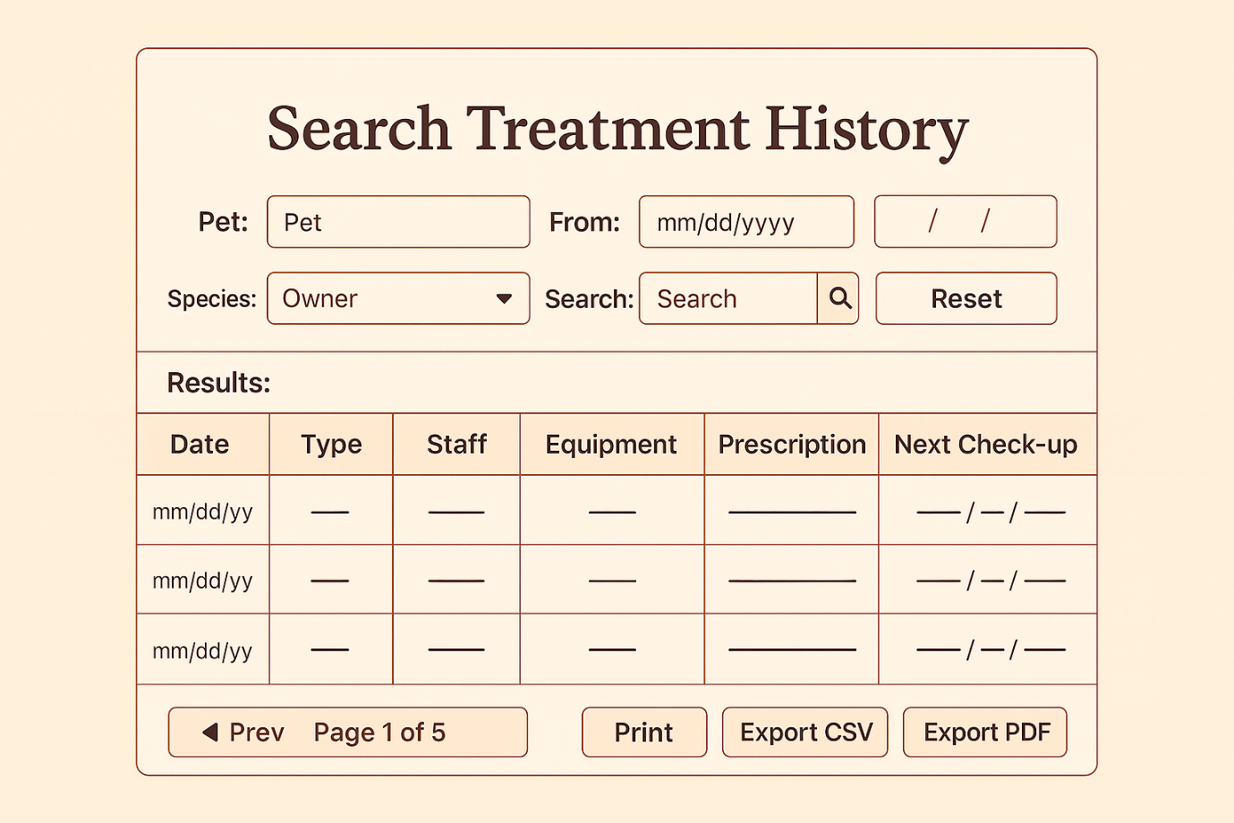

- Filter: Species, Free-text box, Pet (type-ahead), From/To dates, Owner.
- Table of Results Date type of treatment, staff, equipments, prescription, follow-up; Print / Export CSV / Export PDF.
- Behaviour: This query shall be a combination of the Treatment - Pet - Owner query, a combination where the Staff and Equipment name will be agglomerated on the junction tables in a format that is easy to read.
These wireframes adhere to the principle feature of usability such as labels, active feedbacks, and dropdowns / search in order to reduce typing errors (Nielsen, 2020).

User/System Requirement Control.
- All the key user actions will also be discussed: the owners / pets will be entered into the reception sector, clinicians will be able to add the treatment records and other staff members and the equipment can be a part of the treatment process, treatment records can be searched and exported by the remaining staff.
- The system settings are switched on as follows: dropdowns/search, dropping invalid dates, being a correct foreign key relationship, Save order (Treatment then junction rows) keeps relationships, name, and date index allow to find the data faster.
- The UI is also easy to train since all the screens are interconnected to one or two tables

ERD and Logical schema analysis.
Strengths:
- The real life relationships are also sufficiently described (Owner-Pet 1:M: Pet-Treatment 1:M: Treatment-Staff and Treatment-Equipment M:N).
- The junction tables enable the elimination of redundancy and eradicate the update hazard.
- UC mapping Simple UI mapping: Access/write The tables required by every action are accessed/written when they are required - RI is simple to maintain.
- Add, delete appointments and billing without disintegrating the existing keys, send email and such like.
Weaknesses / possible solutions:
- Further search was treatments that are segregated as No, Street, District and Post code.
- The application is essentially a security application in which some one might be asked to provide security as an option, one has an opportunity to provide database roles, views and audit columns.
- Stock and financial module (Invoices, Payments, Stock Items, etc.) modelling is not used.

Conclusion
The problems of Paws and Whiskers are resolved using the establishment database. It contains the data in the readable format, it is relational due to the referential integrity and non redundant and it is 3NF. The reason behind these screens is that the clinic employees can easily add pet and owners, and update on treatment and history of treatment within a limited time.
This design can be implemented in the day to day operations of a small clinic according to the established principles of databases and it can also be extended to other desirable attributes like billing or even making of appointment.

Activity 2 - Creating a database (Paws and Whiskers)

Introduction
This activity will import the database used in activity 1 into a running MySQL database. The aim is to make the paws and whiskers veterinary clinic forget the paper record system and begin to adopt an extremely well-organized electronic system that is easily serviced.
This report includes:
- SQL statement, which will be used to create the tables and the corresponding primary and foreign keys.
- The database is bound to the user interface (the drawings in the wireframes in activity 1).
- Delete command to maintain data integrity.
- A phpMyAdmin tiny web or phpMyAdmin Security.
- The build in is rapidly evaluated to fulfill the requirements of the clinic.
- Seven assignments have examples and solutions to SQL queries.
It is framed with a set of common principles of database such as relational modelling, referential integrity and normalisation (Connolly and Begg, 2019; Murach, 2021; MySQL Documentation, 2024).

2.1 SQL Development and Security.

SQL DDL - Creating Tables
- This database has 5 entity tables and 2 junction tables, which is a many to many relationship.
- We can run the following SQL statements in phpMyAdmin - SQL tab.
- The two orders are given chronologically, to avoid confusion.

Owner Table
CREATE TABLE Owner (
OwnerID INT AUTO_INCREMENT PRIMARY KEY,
FirstName VARCHAR(50) NOT NULL,
LastName VARCHAR(50) NOT NULL,
Address VARCHAR(200),
Phone VARCHAR(20),
Email VARCHAR(100));

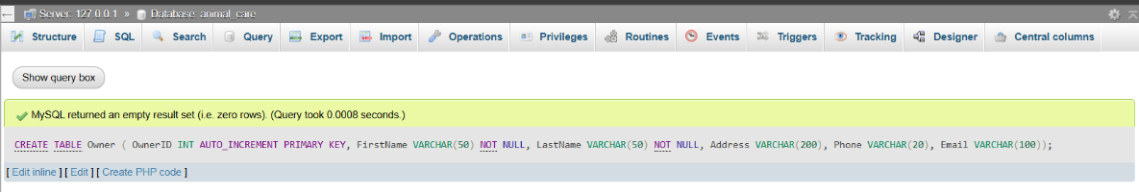
- This table keeps contact information for each pet owner.
- The OwnerID acts as the unique identifier.

Pet Table
CREATE TABLE Pet (
PetID INT AUTO_INCREMENT PRIMARY KEY,
Name VARCHAR(50) NOT NULL,
Species VARCHAR(50) NOT NULL,
Breed VARCHAR(50),
DOB DATE,
Gender VARCHAR(10),
OwnerID INT NOT NULL,
FOREIGN KEY (OwnerID) REFERENCES Owner(OwnerID)
);
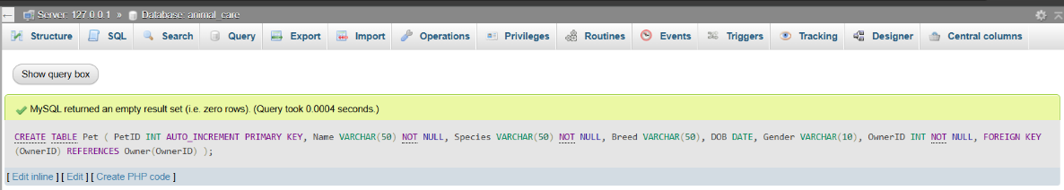

- This links each pet to the correct owner using OwnerID as a foreign key.
- It ensures that no pet exists without a registered owner.

Staff Table
CREATE TABLE Staff (
StaffID INT AUTO_INCREMENT PRIMARY KEY,
FirstName VARCHAR(50) NOT NULL,
LastName VARCHAR(50) NOT NULL,
DOB DATE,
Qualification VARCHAR(100),
Role VARCHAR(50),
Phone VARCHAR(20),
Email VARCHAR(100),
Address VARCHAR(200)
);

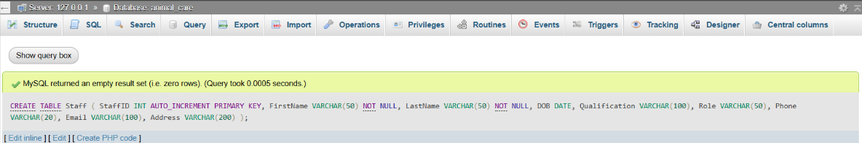
- This stores clinic staff details such as vets, nurses, and groomers.

Treatment Table
CREATE TABLE Treatment (
TreatmentID INT AUTO_INCREMENT PRIMARY KEY,
TreatmentType VARCHAR(100) NOT NULL,
`Date` DATE NOT NULL,
Prescription TEXT,
NextCheckupDate DATE,
PetID INT NOT NULL,
FOREIGN KEY (PetID) REFERENCES Pet(PetID)
);
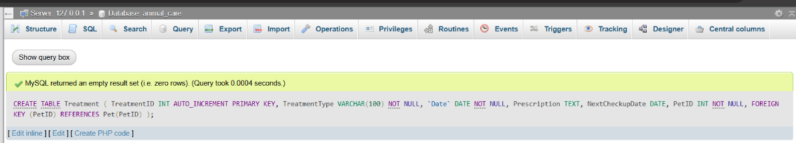

- The Treatment table records every session provided for a pet, including the next follow-up date
Equipment Table
CREATE TABLE Equipment (
EquipmentID INT AUTO_INCREMENT PRIMARY KEY,
EquipmentType VARCHAR(50) NOT NULL,
MaintenanceDate DATE,
AvailabilityStatus VARCHAR(20));

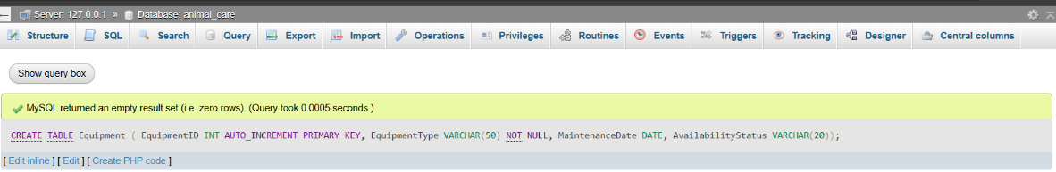

Junction Tables for M:N Relationships
Because one treatment can involve several staff members and use several equipment items, we need two junction tables.
- CREATE TABLE Treatment_Staff (
TreatmentID INT NOT NULL,
StaffID INT NOT NULL,
RoleInTreatment VARCHAR(50),
PRIMARY KEY (TreatmentID, StaffID),
FOREIGN KEY (TreatmentID) REFERENCES Treatment(TreatmentID),
FOREIGN KEY (StaffID) REFERENCES Staff(StaffID)
);
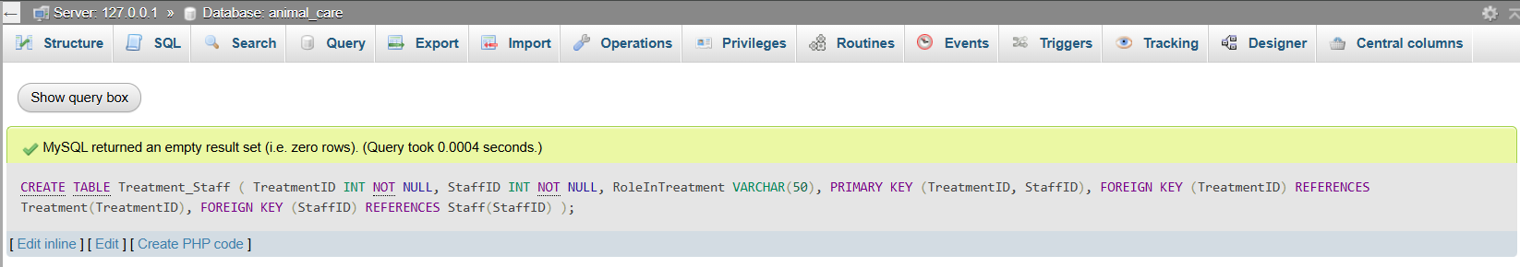

- CREATE TABLE Treatment_Equipment (
TreatmentID INT NOT NULL,
EquipmentID INT NOT NULL,
PRIMARY KEY (TreatmentID, EquipmentID),
FOREIGN KEY (TreatmentID) REFERENCES Treatment(TreatmentID),
FOREIGN KEY (EquipmentID) REFERENCES Equipment(EquipmentID)
);
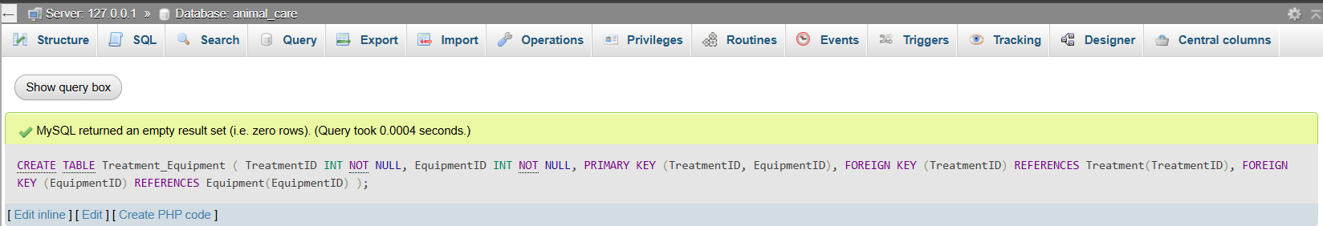
- These tables prevent duplication and keep track of which staff and tools were used for each treatment.

SQL Interaction with Screens.
- The wireframe database option operates so:
- Add, treat, search/export, and even how to safely delete.

A) Adding a New Pet
Add Pet, the following fields: Pet Name, Species, Breed, Gender, DOB, Owner (dropdown search).
Process:
- We pattern gaps with continuities.
- Adds an owner to an owner list.
- Clicks Save.
Validation:
- Fields cannot be left blank.
- DOB cannot be a future date.
INSERT INTO Pet (Name, Species, Breed, DOB, Gender, OwnerID)
VALUES ('Buddy','Dog','Labrador','2020-05-12','Male', 1);
- The OwnerID must exist in the Owner table because of the foreign key, ensuring data consistency.
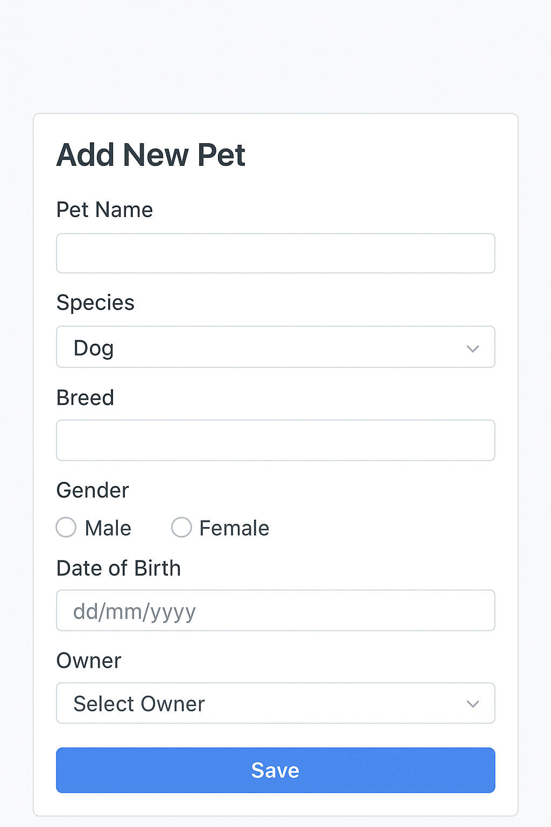

B) Recording a Treatment
Treatment screen with treatment information, pet and staff screens, and equipment screens.
Process:
- Clinician selects the pet.
- Treatment dates and information were available.
- Chooses the staff involved.
- Picks the equipment used.
- Saves the record.
SQL steps in order:
Step 1: Insert treatment
INSERT INTO Treatment (TreatmentType, `Date`, Prescription, NextCheckupDate, PetID)
VALUES ('Vaccination','2024-02-10','Rabies Dose 1','2025-02-10', 1);
Step 2: Link staff
INSERT INTO Treatment_Staff (TreatmentID, StaffID, RoleInTreatment)
VALUES (LAST_INSERT_ID(), 1, 'Lead Vet');
Step 3: Link equipment
INSERT INTO Treatment_Equipment (TreatmentID, EquipmentID)
VALUES (LAST_INSERT_ID(), 1);

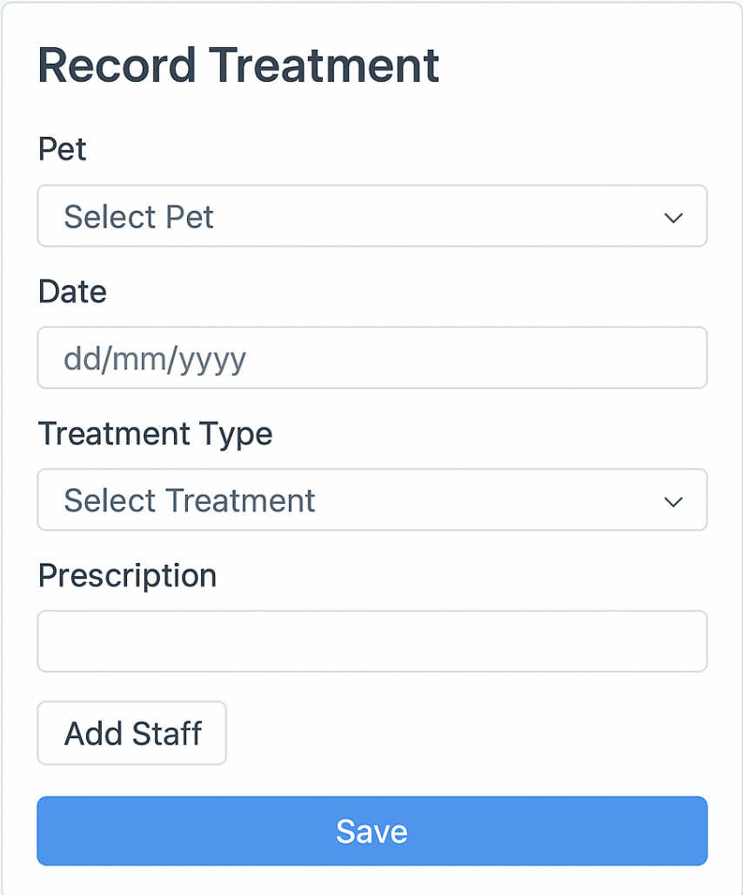

C) Deleting a Treatment Safely
To maintain referential integrity, we must remove linked child records before deleting the treatment itself.
DELETE FROM Treatment_Staff WHERE TreatmentID = 1;
DELETE FROM Treatment_Equipment WHERE TreatmentID = 1;
DELETE FROM Treatment WHERE TreatmentID = 1;
If we try to delete the parent treatment first, MySQL will show a foreign key constraint error, which proves that the data protection is working.
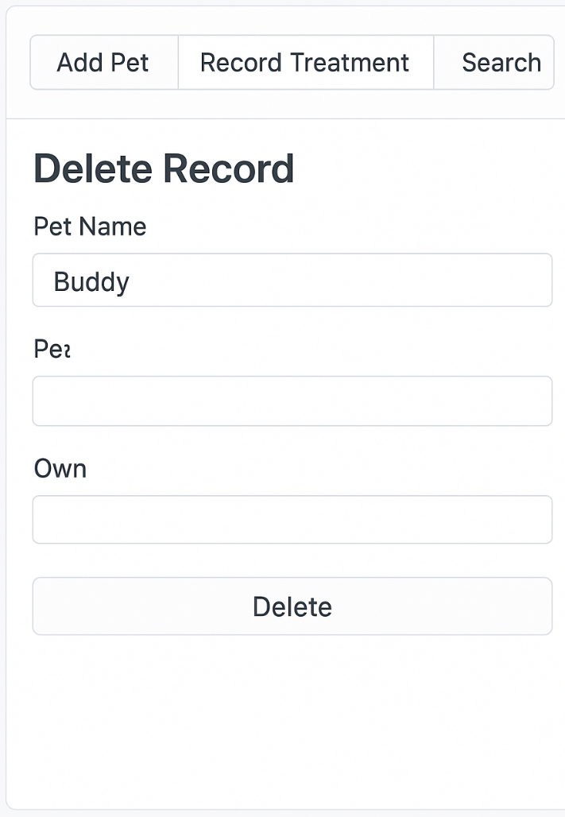

Security Practices
Its student project but some work on security it can work with safety.

User roles and permissions:
- Receptionist: include owners/pets and history.
- Vet/Nurse: Add or edit treatments.
- Admin: can control machines and people.
- It is as by bare right.

Authentication:
- Use username and password.
- Store passwords as hashes and not as unhashes.

Safe SQL:
- Always code the statements using PHP, to avoid SQL injection attacks (OWASP, 2021).

Input validation:
- Identify fields and suitable dates to use on forms.
- Foreign keys cannot have invalid links.

Backups:
- Please ensure that you are backing up the database daily.
- You already have a restore process.

Audit trail:
- We then need to add some columns like CreatedAt and UpdatedAt to monitor any changes in future.

Evaluation - Build vs Needs
This database created is the same as the one created in the 1st activity.
- It has two junction and five entities tables.
- The key primaries and the foreign key enforce all relations of the types 1:M and M:N.
- The auto-increment is fast at saving some data.
- The screens Add Pet and Record Treatment seem to be connected with the database.
- In search screens and in export screens, some data can be recovered with a simple SQL join.
- Referential integrity helps to ensure consistency of data.
- Low-level jobs and sensitive data and information to the owners being monitored by these security guards.
- The daily baking could reduce the risk of loss of data.
It is a straightforward and efficient solution, applicable to a small clinic like Paws and Whiskers, and it offers a chance to grow and evolve in the future (Connolly and Begg, 2019; Murach, 2021).

SQL Query Examples

1. SELECT with WHERE
SELECT TreatmentType, `Date`
FROM Treatment
WHERE PetID = 1 AND TreatmentType = 'X-ray';

- Helps vets check all X-ray treatments for a pet.

2. UPDATE treatment follow-up date
UPDATE Treatment
SET NextCheckupDate = '2024-03-15'
WHERE TreatmentID = 1;

- Fixes an incorrect follow-up date.

3. BETWEEN two dates
SELECT TreatmentID, PetID, `Date`
FROM Treatment
WHERE `Date` BETWEEN '2023-01-01' AND '2023-12-31';

  - Useful for annual reports.

4. IN a list of roles
SELECT StaffID, FirstName, LastName, Role
FROM Staff
WHERE Role IN ('Veterinarian','Vet Nurse','Groomer');

  - Helps build rotas for clinical staff.

5. GROUP BY species
SELECT Species, COUNT(*) AS PetCount
FROM Pet
GROUP BY Species;

- Shows how many pets of each species visit the clinic.

6. ORDER BY pet name
SELECT PetID, Name, Species
FROM Pet
ORDER BY Name ASC;

- Easy alphabetical list for reception.

7. HAVING to find frequent patients
SELECT PetID, COUNT(*) AS NumTreatments
FROM Treatment
GROUP BY PetID
HAVING COUNT(*) > 3;

- Flags pets needing extra attention.

Why These Queries Matter?
The questions support real world activities:
- Vets would like to be able to find out whether a procedure has taken place in an animal (SELECT/WHERE).
- The workers enters the erroneous follow-up dates (UPDATE).
- A range of clinical work is surveyed (BETWEEN).
- HR staff build rotas (IN).
- The clinic also monitors interactions of species among patients (GROUPBY).
- The lists of pets are arranged in alphabetical order through Reception (QUICK SEARCH).
- Teams choose high-need pets (HAVING > 3).

Write SQL queries for each of the following tasks using the developed database.

Dogs owned by people in York
SELECT p.Name AS Pet, o.FirstName, o.LastName
FROM Pet p
JOIN Owner o ON p.OwnerID = o.OwnerID
WHERE p.Species = 'Dog' AND o.Address LIKE '%York%';

Change breed of pet named 'Max'
UPDATE Pet
SET Breed = 'Golden Retriever'
WHERE Name = 'Max';

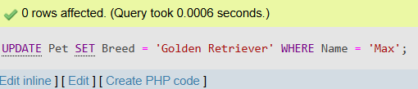

List all treatments in 2023
SELECT TreatmentID, PetID, TreatmentType, `Date`
FROM Treatment
WHERE `Date` BETWEEN '2023-01-01' AND '2023-12-31';

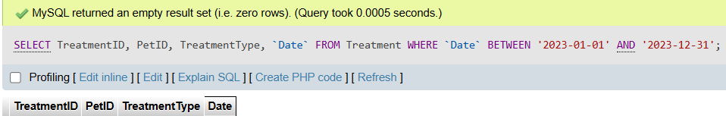

Staff with clinical roles
SELECT StaffID, FirstName, LastName, Role
FROM Staff
WHERE Role IN ('Veterinarian','Vet Nurse','Groomer');

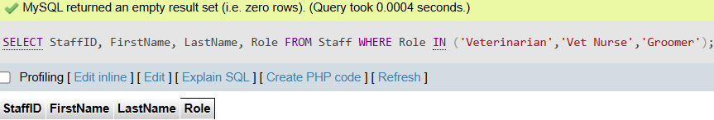

Count pets by species
SELECT Species, COUNT(*) AS PetCount
FROM Pet
GROUP BY Species;

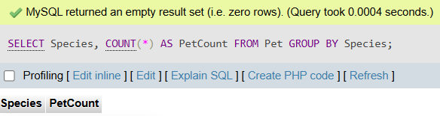

Alphabetical list of pets
SELECT PetID, Name, Species, Breed
FROM Pet
ORDER BY Name ASC;

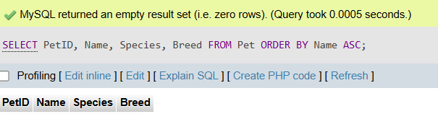

Species with more than two pets
SELECT Species, COUNT(*) AS PetCount
FROM Pet
GROUP BY Species
HAVING COUNT(*) > 2;

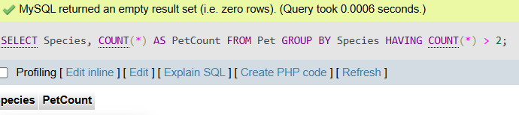

Conclusion
A successful development of Paws and Whiskers Animal Care database in MySQL employed the design of activity 1. It provides a five-entity and two-junction-table framework that covers all significant clinic functions. Foreign keys guarantee referential integrity, and simple SQL offers personnel easy access to data to update and report on. It also aligns with other fundamental security policies role, safe SQL and backups, which the clinic uses daily. Overall, implementation is possible and easy to use and can be updated to any future developments as the clinic finds new services to offers

Activity 3 – Testing and Feedback (Paws & Whiskers Animal Care)

Introduction
The operation to be undertaken would be to test the database system that has been developed in Paws and Whiskers Animal Care. The goal is to make the database meet both the user requirements (e.g. adding pets to the database, adding treatments performed on pets to the database), and the system requirements (e.g. good foreign-key relationships, reliable queries, good performance). Testing is valuable because any properly designed system can have some errors when implemented. Some problems with a test plan, clear scenarios, test data, expected and actual results can be identified and fixed. The feedback of the user (e.g. the feedback of receptionists) and the technical feedback (e.g. the feedback of developers) can be helpful in their work to make the system not only right but easy and safe to use. It is also tested using the standard practice of database-testing available in Connolly and Begg (2019), Murach (2021) and MySQL documentation (2024). The principles of the general usability assessment upon which the feedback method is built are developed by Nielsen (2020).

3.1 Testing

Test Plan Table
The three of the five test cases listed below are employed to address the most prominent user activities and system policies in Paws and Whiskers database. It uses the following columns:
Test Scenario, Test Data, Expected Result, Actual Result, Pass/Fail.

Test Scenario | Test Data | Expected Result | Actual Result | Pass/Fail
Add a new pet for an existing owner | Pet Name = “Buddy”; Species = “Dog”; Breed = “Beagle”; DOB = 2021-05-15; Gender = “Male”; OwnerID = 1 | Row is added to Pet table with correct link to OwnerID=1; success message shown | Row inserted successfully; PetID auto-generated | Pass
Prevent adding pet with DOB in future | Pet Name = “Kitty”; DOB = 2030-01-01 | System rejects input; error message “DOB cannot be in the future” | Validation error shown; row not inserted | Pass
Record a treatment with one vet and one equipment item | TreatmentType = “Vaccination”; Date = 2024-06-10; Prescription = “Rabies dose 1”; NextCheckup = 2025-06-10; PetID=1; StaffID=2; EquipmentID=1 | One row added to Treatment table; one row in Treatment_Staff; one row in Treatment_Equipment | All rows inserted as expected; IDs linked correctly | Pass
Delete a treatment safely | TreatmentID = 5 | When delete is attempted directly on Treatment, DB rejects due to FK constraint; after deleting from junction tables first, delete succeeds | Behaves as expected; confirms RI is enforced | Pass
Search treatment history for pet “Buddy” in 2024 | PetID = 1; Date range = 2024-01-01 to 2024-12-31 | Query returns all treatments for Buddy in 2024, ordered by date | Query result correct and matches sample data | Pass

The most common cases of these five cases are adding, validating, linking, deleting and searching.

Choice of Test Data
To simplify test data while still being realistic, after real operations in the clinic, the test data was chosen as follows:
- The model-valid situation: another healthy pet is introduced to an owner.
- Case of validation: (Trying to add a pet with future date of birth to test date-rule enforcement).
- A linking case: reporting of treatment in case of linking treatment of employees and machinery.
- One example of a referential integrity: an effort to delete a treatment whilst rows that are linked to the treatment are not removed.
- Search/reporting: locating the treatment history of a pet over a given time frame, is one of those cases.
This is a combination that does not only provide verification of the user functions but also the system constraints like the foreign-key integrity and validation constraints. It is well suited to a small clinic database because it includes names, dates that are easy to read and reveal the problems, in case the database is not set up correctly (Murach, 2021).

Testing Results and Recommendations to improve testing.
The system will be sensitive to the following:
- All (including registering treatment, searching history and adding pet) was working as anticipated.
- Future DOB validation was successful; invalid input into the system was suppressed.
- Referential integrity was also checked: the database would not allow them to delete a treatment whose staff/equipment records were not yet connected to it.
- The search query used was pet and date to philtre out the correct data

Areas tested that require improvement:

User messages:
The default messages of FK violation in MySQL or phpMyAdmin are not user friendly. A clearer message should be displayed in case of a working web application like: It ought to be deleted that linked staff/equipment shall be removed before this treatment is deleted.

Input validation in forms:
Currently, it was only the validation of DOB that was tested. make the checks mandatory (e.g. the treatment type may not be left blank, the structure of the phone number of the owners).

Search flexibility:
It has a search home page that operates under PetID and date range.
Suggestion: an optional addition of a philtre by the staff member or by the type of treatment is recommended in order to be able to find specific cases the fastest way.

Performance for larger data:
The search is fast when the test data are small.
Suggestion: in case the data grows, it is recommended to add the corresponding indexes to both columns in search and to the column in joins (PetID, TreatmentDate, StaffID) as recommended by MySQL (2024).
These would not change the database structure itself but would facilitate this system and make it more decisive.

3.2 User & Developer Feedback

Feedback Questionnaires
Two short questionnaires were created, a non technical user (a receptionist) and a technical user (developer or IT support).

A) Non technical user (receptionist)
- How easy was it to add a new pet?
- Was the error message noticeable when you entered an invalid date?
- The records of treatment of a pet are so easy to find out?
- Do you find the drop down lists and labels on the screen understandable?
- What do you wish the system to do to enable you work quicker?

B) Developer / IT Technician
- Was MySQL/phpMyAdmin database easy to instal and utilise?
- Can you understand the name of the tables and the relationship between the tables easily?
- Did the constraints and foreign keys meet your expectation?
- Does SQL code have a maintainable clean code?
- What technical improvement would you recommend (e.g. indexing, security)?

Other Feedback Major Recommendations.
From receptionist:
- Would rather have a better notice to deletion of treatment.
- Suggested the search box on the home page which would be in a position to search pets by their names.
- A dropdown list is an advantageous one as it reduces typing errors.
From developer:
- Assured that the ERD and schema were readable and that the FK constraints were working.
- It was advised that index should be added on frequently accessed columns so as to ensure good performance during the increment of the data.
- Auditing was recommended when the content (CreatedBy column) was logged in.

Implication of the Feedback on the Design.
According to the feedback, the following improvements and plans were implemented:
- Better error and warning messages:
Fully computerised to be installed later in order to make the user aware of the reason why a given action has failed.
- Additional search and filter capabilities:
To make sure it is quicker when personnel members are searching cases.
- Other audit and performance attributes:
Will add index and CreatedBy field in Treatment table in version 2.
The importance of feedback was also valid because the original design (tables, keys, constraints) was correct and the changes were more preoccupied with the usability and further development. It implies that the database solution is meaningful yet can be enhanced.

Conclusion
Paws and Whiskers database testing allowed seeing that the developed system in activity 2 is identical to the one in activity 1 and meets the requirements of the primary user and system. Most important functions, i.e. adding pets, data validity, treatments record, referential integrity and search history were tested. All this went by suggesting that the basic database is sound. Testing was also used to identify areas of future development, with the majority of these areas pertaining to ease of use (improved messages and flexible search) and technical development (indexes, audit logging). The impressions and experience of a receptionist and a developer proved to be useful and made it possible to make the system more convenient and cheque whether the design is effective.
Overall, testing and feedback process have shown that the database of Paws and Whiskers is a stable and a helpful solution to the work of the clinic on the basis of which the further upgrade may be attained.

Activity 4 - Documentation (Paws and Whiskers Animal Care).

Introduction
The following exercise is guided by the documentation of the database system developed on Paws and Whiskers. Documentation is crucial as it helps the technical staff (including the developers or the IT assistance to the database) and the non-technical staff (including the receptionists and the vets) to learn how the database works and how to use the database without exposing the information, which might be vital, to any risks.
A documentation package comprises of;
- Technical documentation - a description of the tables, relationships, constraints, diagrams and validation rules so that the future system developing staff can maintain or improve the system.
- System diagrams - This is a representation of data flow in the system in form of a flow chart, use-case diagram or a DFD.
- User documentation - simple guidelines on everything one can do on the dailies such as adding pets, recording and reports of the treatment.
- Suggestion of how it can be better in the future - features that will make the system effective as the clinic grows.
Below the paper is reported under the description of best practises presented by Connolly and Begg (2019), Murach (2021), and Nielsen (2020). It is associated with the design (activity 1), development (activity 2) and testing and feedback (activity 3) phases.

Valuable aspects of technical documentation.
The technical documentation of the Paws and Whiskers database includes the following parts:

a) Database Tables
The entity tables and relationship tables are as follows:
- Owner(OwnerID, FirstName, LastName, Address, Phone, Email)
- Pet(PetID, Name, Species, Breed, DOB, Gender, OwnerID FK)
- Staff(StaffID, firstname, lastname, dateofbirth, qualification, position, phone, email, address)
- Equipment(EquipmentID, Equipmenttype, Maintainance Date, Availability Status)
- Treatment( TreatmentID, Treatment Type, Date, Prescription, NextCheckupDate, PetID FK)
- Treatment_Staff(TreatmentID FK, StaffID FK, RoleInTreatment) - Treatment and Staff M:N junction table.
- Treatment_Equipment(TreatmentID FK, EquipmentID FK) - M: N between Treatment and Equipment junction table.
These tables were a verbatim transcription of the ERD in activity 1 and were created on MySQL as mentioned in activity 2.

b) Relationships
- Owner - pet: 1- many pets (one owner can have many pets).
- Treatment -Pet: 1-to-Many (A single pet may get many treatments).
- Answers - Staff: Many-Many (remedied by Treatmen_Staff junction)
- Treatment - Equipment: Man-Many (solved by Treatment_Equipment junction)
These kinds of relationships give the data representative of the real clinic organisation.

c) Diagrams
The documentation includes:
- ERD (Entity-Relationship Diagram) - it represents all entities, primary keys, foreign keys, as well as all cardinalities.
- Wireframe screens - will be needed to bridge the user interface and the tables to Add Pet, Record Treatment, and Search Treatment History.
- Flowchart or DFD - the report of one significant process (see section 23).
The technical employees and students can easily understand the system because of the diagrams.

d) Rules and Constraints of validation.
In the database, there are several rules:
- Each Pet must be attached to a certified Owner (FK constraint).
- Any Treatment must be linked with real Pet.
- Junction tables can only accept valid Treatment, Staff and Equipment IDs.
- DOB of the pet can not be futuristic.
- The next cheque-up date should not be prior to treatment date.
- In order to remove a treatment, one has to delete links of the treatment (in order to preserve referential integrity).
- The most important keys to make the addition of records easy are the auto-increment.
These data integrity rules were tested in Activity 3 (Silberschatz, Korth and Sudarshan, 2020).

e) Security Information
The following user roles grant access to the database: reception, clinician, admin.
- Strong passwords and parameterised queries will help prevent SQL (OWASP, 2021).
- Daily backup schedule.
- The future database can contain CreatedBy and UpdatedAt columns which may be utilised in audit trail.

Flowchart of Pet Treatment search System Diagram.
Flowchart has been chosen because a graphical way of narrating the search treatment history is an easy way. This is essential when the vets and the receptionist need to get the records of previous visits of a pet.

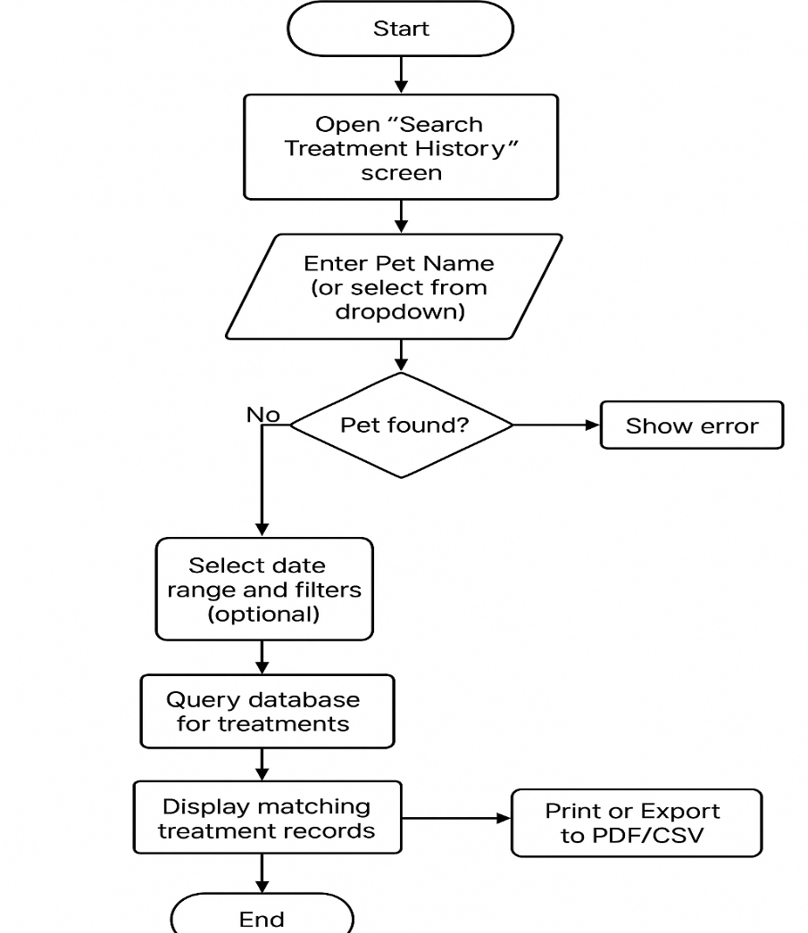

This schema is directly related to this flowchart:
- The input fields ( PetID, TreatmentDate) have indexed columns.
- PiggyJoin Treatment - Pet - Owner and add Staff and Equipment.
The diagrams help the developers and the trainers elaborate on the interface functionality.

User Guide
The user documentation is provided in simple steps that one can easily follow in order to ensure that the non technical staff can easily use the system.

A) Adding Pets
- Enter Owner details.
- Open "Add Pet" screen.
- Type In Name of Pet, Species, Breed, Gender, Date of Birth.
- Select the appropriate Owner in the dropdown (or, to create a new Owner, you must firstly, click +).
- Click Save.
DOB cheques System and the pet are equated with the Owner of choice.
Success message appears.

B) Recording Treatments
- Log in as Vet or Nurse.
- Select the open record treatment screen.
- Select the Pet on search box.
- Insert Type of treatment, date, prescription, date of next cheque.
- Select required Equipment items.
- Click Submit.
System shall make new record in Treatment table automatically and shall be automatically linked with the chosen record of staff and equipment in junction tables.
Message confirmation has been displayed.

D) Generation of Reports / search of history of treatment.
- Log in as Receptionist or Vet.
- Click on search treatment history screen.
- Name of type pet (or pick on drop down).
- Sort by personnel/ treatment type or date.
- Click Search.
The outcome table shows the date, type, employees, equipments, prescription and upcoming cheque-up.
Export Print / Export CSV / Export PDF when required in generating referrals or internal reporting.

Tips for All Users
- Before saving, due care should be taken.
- Wage cuts (in treatments) must only be tried when the staff/equipment is not interconnected.
- Instead of typing in the IDs, drop downs shall be employed to minimise errors.
- The logging in should then be done followed by use.

Next-Generation Improvements and Enhancements.
The database is helping the clinic achieve its basic needs.
However, as the clinic grows, the suggested improvements are as follows.

A) New Features
- Appointment scheduling module - to plan the future visits and grant the notification.
- Bills and history of payment - to determine the relationships between treatments and bills and receipts.
- SMS/email notification - medical check up and vaccination.
- Audit trail - to identify the individual who accessed this or that treatment.

B) Performance Enhancements
- When data is growing add column indexes on commonly searched data, including PetID, TreatmentDate, StaffID.
- Old records may be stored in such a way that the tables employed are highly light and quick.
- Monitor query execution plans to verify their slow users.

C) interface and enhancement in the user experience.
- Go with a more updated frontend (e.g. React or Angular).
- Provide mobile services to pilots in the field.
- Incorporate more interactive graphs (species of treatment, income statements, and so on).
- Get the error messages more readable (e.g. explain the FK errors in non technical words).
These extensions are grounded in the comments on the activity 3 and the system will not turn out to be useless or inapplicable.

Conclusion
The paper which is written in the course of this activity can be regarded as the full source of the reference to both the technical and the non-technical audience. The technical documentation comprises tables, relationships, validation rules and diagrams. Flowchart has defined one of the key processes. User manual provides assistance to the receptionist and vets on adding pet, treatment records, and reports. The recommendations demonstrate how the database can be better to accommodate more processes, more data, and experience. It demonstrates that the system is appropriate and can be used at the time but can be improved in future.

References
Connolly, T. and Begg, C. (2019) Database Systems: A Practical Approach to Design, Implementation, and Management. 7th edn. Harlow: Pearson.
Murach, J. (2021) Murach’s MySQL. 3rd edn. Fresno: Mike Murach & Associates.
MySQL Documentation (2024) MySQL 8.0 Reference Manual. Available at: https://dev.mysql.com/doc/ (Accessed: 4 October 2025).
Nielsen, J. (2020) Usability Engineering. Rev. edn. San Francisco: Morgan Kaufmann.
OWASP (2021) OWASP Top 10: Injection Prevention. Available at: https://owasp.org/ (Accessed: 4 October 2025).
Silberschatz, A., Korth, H.F. and Sudarshan, S. (2020) Database System Concepts. 7th edn. New York: McGraw-Hill.
Connolly, T. & Begg, C. (2019) Database Systems: A Practical Approach to Design, Implementation, and Management. 7th edn. Harlow: Pearson.
Murach, J. (2021) Murach’s MySQL. 3rd edn. Fresno: Mike Murach & Associates.
MySQL Documentation (2024) MySQL 8.0 Reference Manual. Available at: https://dev.mysql.com/doc/ (Accessed: 30 September 2025).
OWASP (2021) OWASP Top Ten: Injection. Available at: https://owasp.org/Top10/ (Accessed: 30 September 2025).
Codd, E.F. (1970) ‘A Relational Model of Data for Large Shared Data Banks’, Communications of the ACM, 13(6), pp. 377-387.
Connolly, T. and Begg, C. (2015) Database Systems: A Practical Approach to Design, Implementation and Management. 6th edn. Harlow: Pearson.
Elmasri, R. and Navathe, S.B. (2016) Fundamentals of Database Systems. 7th edn. Boston: Pearson.
MySQL (2024) MySQL Reference Manual. Available at: https://dev.mysql.com/doc/
Nielsen, J. (2020) Usability Engineering. Rev. edn. San Francisco: Morgan Kaufmann.
Silberschatz, A., Korth, H.F. and Sudarshan, S. (2020) Database System Concepts. 7th edn. New York: McGraw-Hill.
Connolly, T. and Begg, C. (2019) Database Systems: A Practical Approach to Design, Implementation, and Management. 7th edn. Harlow: Pearson.
Murach, J. (2021) Murach’s MySQL. 3rd edn. Fresno: Mike Murach & Associates.
MySQL Documentation (2024) MySQL 8.0 Reference Manual. Available at: https://dev.mysql.com/doc/ (Accessed: 3 October 2025).
Nielsen, J. (2020) Usability Engineering. Rev. edn. San Francisco: Morgan Kaufmann.

